TASK 2
Introduction
Cybersecurity is the practice of protecting computers, networks, applications, and information from unauthorized access, damage, or misuse. As we use the internet for banking, education, communication, shopping, and many other activities, protecting digital information has become very important.
There are several basic concepts that help us understand cybersecurity. The CIA Triad is one of the most important foundations of cybersecurity. CIA stands for Confidentiality, Integrity, and Availability.
This report explains the three parts of the CIA Triad along with two additional concepts: Authentication vs. Authorization and Encryption vs. Hashing. Each concept is explained using a real-world situation.

Objectives
- To understand the three principles of the CIA Triad.
- To understand how cybersecurity concepts are used in real life.
- To understand the difference between authentication and authorization.
- To understand the difference between encryption and hashing.
- To learn why these concepts are important for protecting digital information.
CONFIDENTIALITY

Meaning
Confidentiality means making sure that information is seen only by people who are allowed to see it.
For example, your bank account password should be visible only to you and securely handled by the banking system. Other people should not be able to read it.
Confidentiality can be protected using methods such as passwords, access controls, encryption, and multi-factor authentication.

Real-world scenario
Imagine that you are using a banking application to transfer money. You enter your username, password, account details, and the amount you want to transfer.
When the banking application communicates with its server, the information should be protected so that someone monitoring the network cannot simply read your password or banking details.
Now imagine that the connection is not properly protected and an attacker is able to capture the information being sent. If the attacker can read the customer's password or account details, confidentiality has been violated.
The information was supposed to be available only to the customer and the authorized banking system, but another person was able to see it.

Why confidentiality is important
Confidentiality is important because many types of information are private. Examples include:
- Passwords
- Bank account details
- Personal messages
- Medical information
- Student records
- Business information

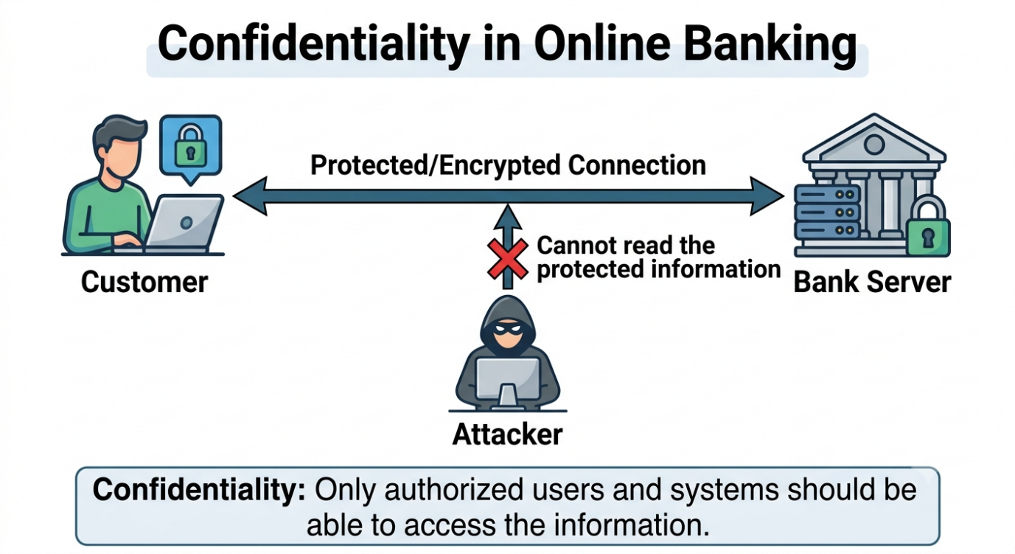

INTEGRITY

Meaning
Integrity means making sure that information remains correct and has not been changed by an unauthorized person.
Information should remain accurate from the time it is created until the time it is used.

Real-world scenario
Imagine that you make an online bank transfer of ₹5,000.
The bank receives the transaction and records that you want to transfer ₹5,000.
Now suppose an attacker somehow changes the transaction amount from ₹5,000 to ₹50,000 without your permission.
The information is no longer correct. The original transaction was ₹5,000, but the system is now processing ₹50,000.
This is an example of an integrity violation because the data was changed without authorization.
Banks and other organizations use different security mechanisms to detect or prevent unauthorized changes.

Why integrity is important
Integrity is important in situations where incorrect information can cause problems.

Examples include:
- Bank transactions
- Examination marks
- Medical records
- Employee salaries
- Government records
- Software files
If a student's mark is changed from 85 to 55 without permission, the information is no longer trustworthy. This shows why integrity is important.

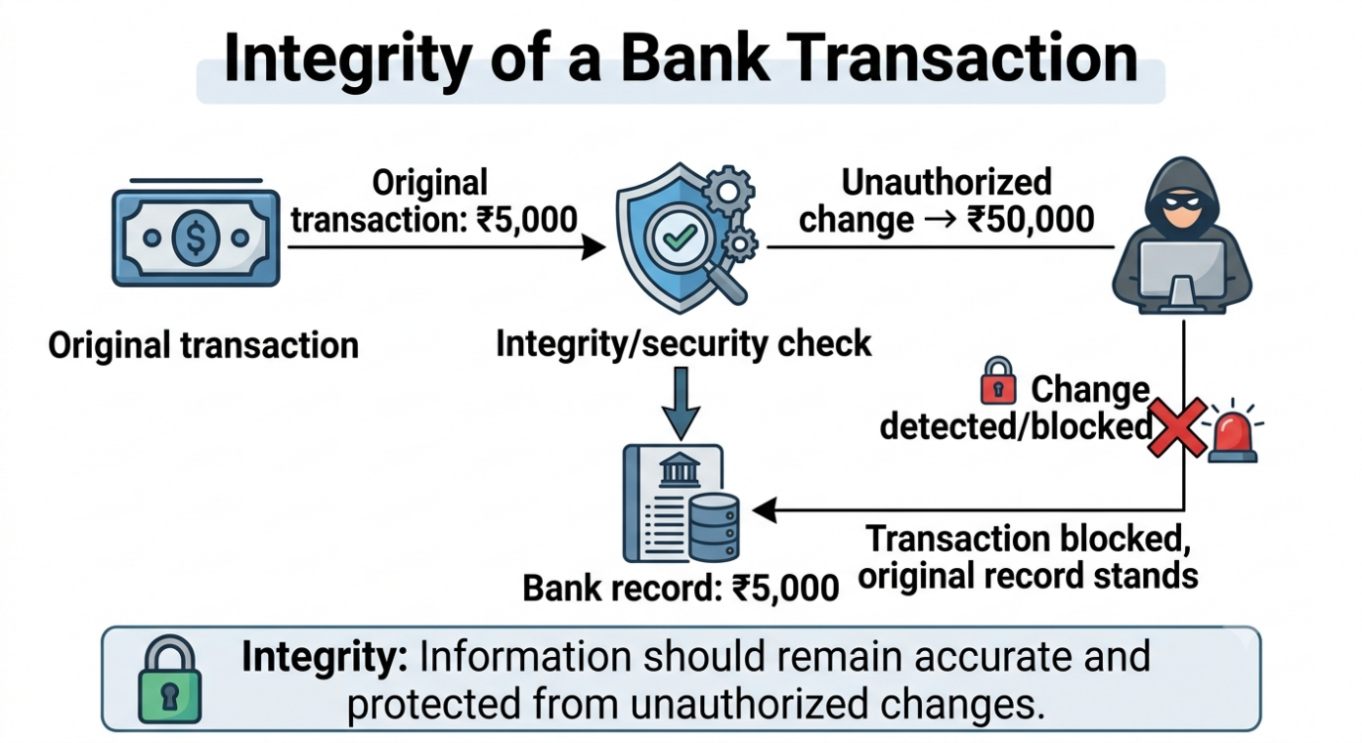
AVAILABILITY

Meaning
Availability means that authorized users should be able to access a system or information when they need it.
A system may have strong passwords and protect its data properly, but it is still a problem if legitimate users cannot access it.

Real-world scenario
Imagine that your college has an online examination portal. Students have to log in and submit their answers before a particular deadline.
On the final day, thousands of students try to access the website at the same time. The server becomes overloaded and stops responding properly.
Students may see messages such as:
"Server unavailable"
or
"Request timed out."
As a result, students cannot submit their examinations even though they have valid accounts.
This is an availability problem because the authorized users cannot access the service when they need it.
Availability can also be affected by a denial-of-service attack, where an attacker deliberately sends a very large number of requests to a service in an attempt to make it difficult for normal users to access.

Why availability is important
Availability is important for:
- Online banking
- College portals
- Websites
- Emergency services
- Online classes
- Cloud storage
- Business applications

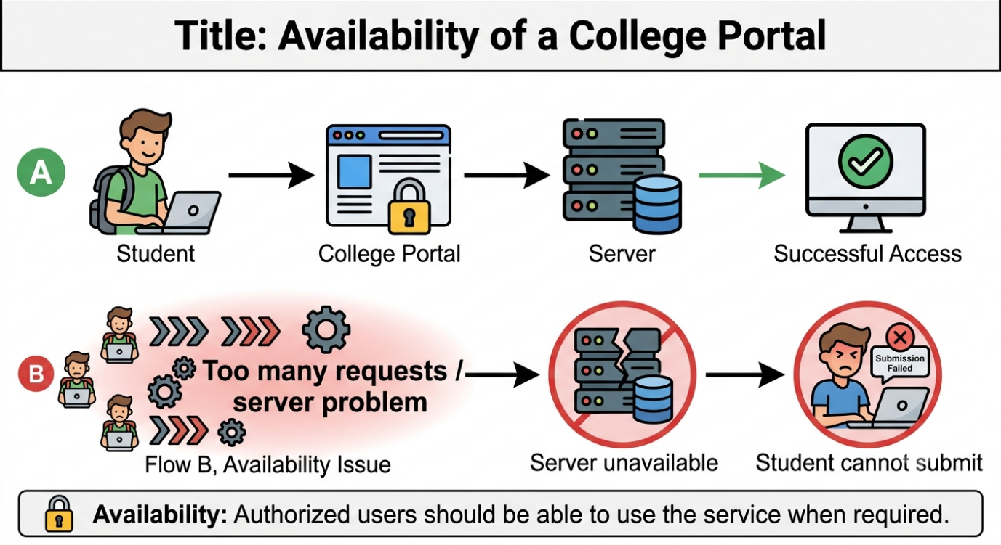

AUTHENTICATION vs AUTHORIZATION

Authentication
Authentication answers:
"Who are you?"
It is the process of verifying someone's identity.
Examples include:
- Password
- PIN
- Fingerprint
- Face recognition
- Security key
- One-time password

Authorization
Authorization answers:
"What are you allowed to do?"
After a person has been authenticated, the system checks what permissions that person has.
For example, an employee may be allowed to view normal company documents but not salary information.

Real-world scenario
Imagine a company has an internal computer system.
An employee enters their username and password.
The system checks the credentials and confirms that the person is really that employee.
This is authentication.
After logging in, the system checks the employee's role.
Suppose the employee is an intern. The intern can access training documents but cannot access the company's payroll records.
This permission check is authorization.
So, even though the intern has successfully logged in, they cannot access everything inside the system.
Simple way to remember
Authentication = Who are you?
Authorization = What can you access?

Why both are important
If a system only checks identity but does not properly control permissions, an authenticated user might gain access to information they should not have.
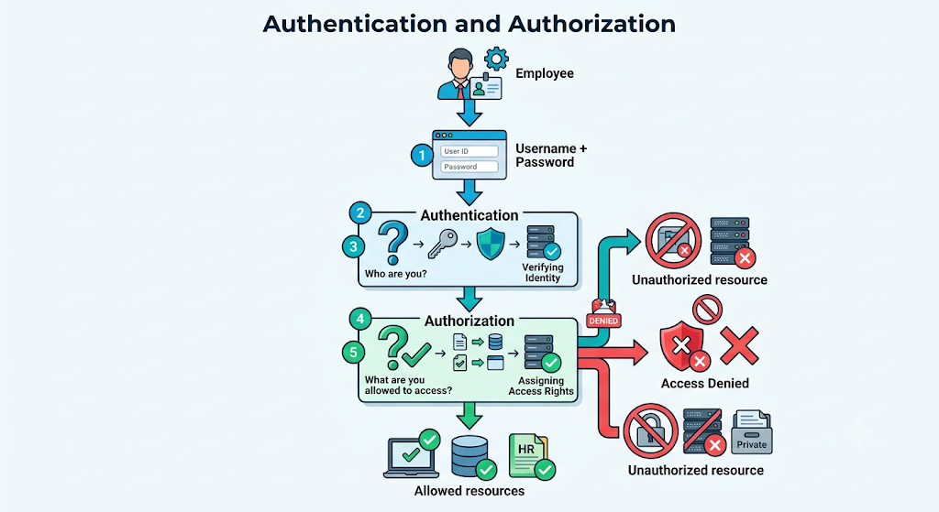

ENCRYPTION vs HASHING

Encryption
Encryption changes readable information into an unreadable form using an encryption method and a key.
The purpose is to protect information so that an authorized person can later recover the original information.
For example:
Original message → Encryption → Unreadable encrypted data
The authorized recipient can use the correct key to decrypt it.

Hashing
Hashing converts information into a fixed-length value called a hash.
A cryptographic hash is designed to work like a one-way fingerprint of the original data. It is not normally intended to be converted back into the original information.
Hashing is commonly used when storing passwords.

Real-world scenario
Imagine that you create an account on a website with a password.
A poorly designed website might store your actual password directly in its database. If the database is stolen, the attacker could see your password.
A better design uses a password-hashing system. The website stores a password hash instead of the original password.
When you log in later, the website processes the password you entered and checks whether the result matches the stored value.
Encryption is different.
Suppose you send a private message to another person. The message needs to remain secret while it is being transmitted, but the intended recipient must eventually be able to read it.
Encryption is suitable for this situation because authorized users can decrypt the protected information.

Feature / Aspect | Encryption | Hashing
Purpose | Protects information from being read | Creates a fingerprint of information
Reversibility | Can be reversed with the correct key | Designed to be one-way
Primary Use Case | Used for messages and files | Commonly used for password storage
Mechanism | Uses encryption/decryption | Uses a hash function

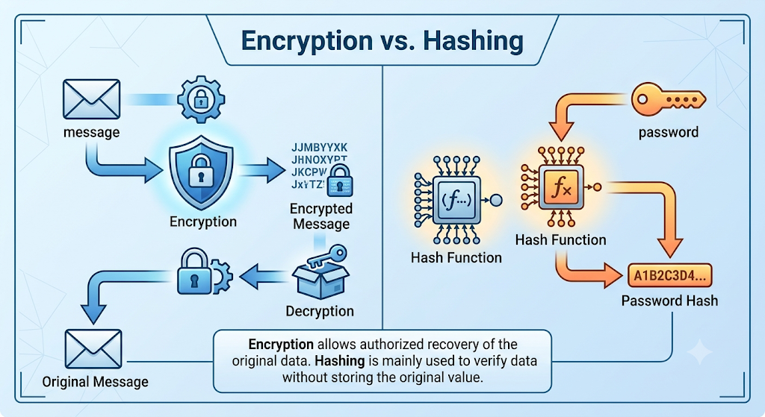

How the Five Concepts Work Together

These concepts are not separate from one another. They often work together in real systems.
For example, consider an online banking application.
Authentication verifies that you are really the account holder.
Authorization determines which banking actions you are allowed to perform.
Confidentiality protects your banking information from unauthorized people.
Integrity helps ensure that your transaction amount is not changed without authorization.
Availability ensures that the banking service is accessible when you need it.
Encryption can protect sensitive information while it is being transmitted or stored.
This shows that cybersecurity usually requires several different protections working together.

